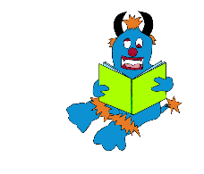 Year 4

Mon 21st & Mon 28th June 2021

Spikey’s Take Away

Learning Menu

English

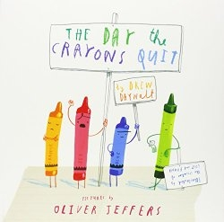

**Story**

Poor Duncan just wants to colour in. But when he opens his box of crayons, he only finds letters, all saying the same thing: We quit!  
Beige is tired of playing second fiddle to Brown, Blue needs a break from colouring in all that water, while Pink just wants to be used. Green has no complaints, but Orange and Yellow are no longer speaking to each other.  
The battle lines have been drawn. What is Duncan to do?

[**https://www.youtube.com/watch?v=489micE6eHU**](https://www.youtube.com/watch?v=489micE6eHU)

# **Lesson 1 -** To share and discuss a story

In this lesson, we will read the story 'The Day the Crayons Quit' and pause throughout to think and answer questions about the text.

[**https://classroom.thenational.academy/lessons/to-share-and-discuss-a-story-c9h36c**](https://classroom.thenational.academy/lessons/to-share-and-discuss-a-story-c9h36c)

# **Lesson 2 –** To explore the features of a persuasive letter

In this lesson, children will look at excerpts from the text 'The Day the Crayons Quit' and look at the features of persuasive letters: exaggeration, emotions, opinions and reasons (argument) and threat.

[**https://classroom.thenational.academy/lessons/to-explore-the-features-of-a-persuasive-letter-cgvked**](https://classroom.thenational.academy/lessons/to-explore-the-features-of-a-persuasive-letter-cgvked)

**Reading - log onto to reading Planet – Rising Stars**

[**https://my.risingstars-uk.com/Default.aspx?ReturnUrl=%2f**](https://my.risingstars-uk.com/Default.aspx?ReturnUrl=%2f)

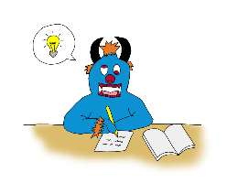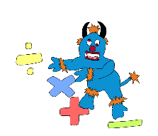

Maths

# **Lesson 1 –** To Identify and describe non-unit fractions

In this lesson, we will use our knowledge of fractions to understand what the term 'non-unit fraction' means. We will explore various shapes and begin to identify the non-unit fraction that is represented.

[**https://classroom.thenational.academy/lessons/to-identify-and-describe-non-unit-fractions-6cr32t**](https://classroom.thenational.academy/lessons/to-identify-and-describe-non-unit-fractions-6cr32t)

# **Lesson 2 –** Fractions: Recognising equivalent fractions (Part 1)

In this lesson, we will explore fractions with different denominators and numerators that are equal to each other.

# [**https://classroom.thenational.academy/lessons/fractions-recognising-equivalent-fractions-1-crt36e**](https://classroom.thenational.academy/lessons/fractions-recognising-equivalent-fractions-1-crt36e)

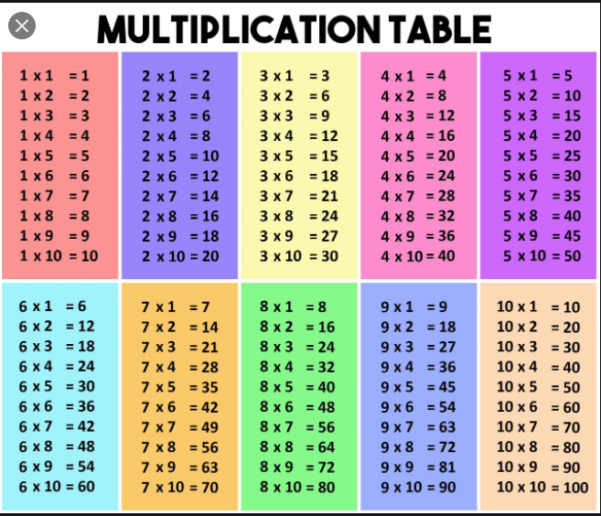**Please log onto Times Tables Rockstar and practise all times tables** [**https://play.ttrockstars.com/auth/school/student/undefined/password**](https://play.ttrockstars.com/auth/school/student/undefined/password)

Spellings

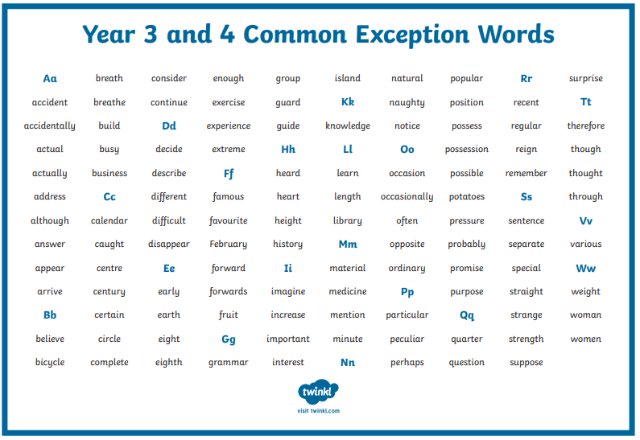

**Please log onto Spelling Frame to practise year group based spellings**

[**https://spellingframe.co.uk/**](https://spellingframe.co.uk/)

# **Lesson 1 -** To investigate suffixes: -tion, -cian, -sion, -ssion

In this lesson, we will investigate the suffixes -tion, -ssion, -sion and -cian.

# [**https://classroom.thenational.academy/lessons/to-investigate-suffixes-tion-cian-sion-ssion-c8up2c**](https://classroom.thenational.academy/lessons/to-investigate-suffixes-tion-cian-sion-ssion-c8up2c)

# **Lesson 2** - To practise and apply knowledge of suffixes: -tion, -cian, -sion, -ssion

# In this lesson, we will practise and apply our knowledge of the suffixes -tion, -ssion, -sion and -cian.

[**https://classroom.thenational.academy/lessons/to-practise-and-apply-knowledge-of-suffixes-tion-cian-sion-ssion-6ngp4c**](https://classroom.thenational.academy/lessons/to-practise-and-apply-knowledge-of-suffixes-tion-cian-sion-ssion-6ngp4c)

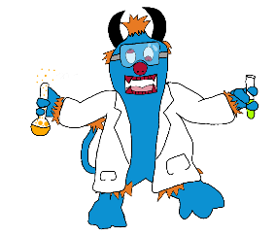

**History**

Railways

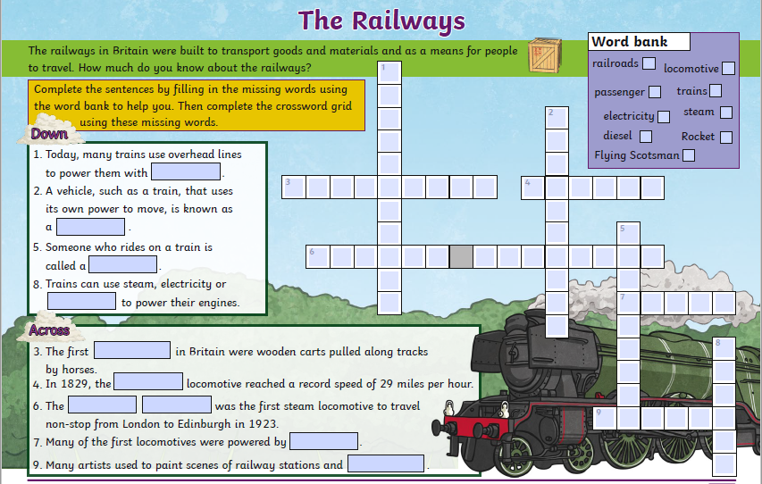

PSHE

Keeping Safe

**Lesson 1-** Hazards in the home

Children will learn what a hazard is and how to spot them in their own homes through a series of images shown. Children will then carry out a basic risk assessment on a room of their choice.

[**https://classroom.thenational.academy/lessons/hazards-in-the-home-6mt68c**](https://classroom.thenational.academy/lessons/hazards-in-the-home-6mt68c)

# **Lesson 2 -** King of the road

Children will be looking at some common road signs and will learn how to keep safe whilst out on a bike. Children will become familiar with the car seat law and create a fact sheet on what they have learnt.

[**https://classroom.thenational.academy/lessons/king-of-the-road-6mu36t**](https://classroom.thenational.academy/lessons/king-of-the-road-6mu36t)

**DT**

# **Lesson 1 -** Understanding how a range of mechanisms create movement.

In this lesson, we will explore a range of mechanisms and how they are made to move. We will think about materials we have at home and how they could be recycled or reused to make mechanisms. We will also introduce you to a design brief, considering how mechanisms could be used to meet the brief.

This lesson includes some physical activity and equipment beyond pen, paper or pencil. Please make sure your child is adequately supervised.

[**https://classroom.thenational.academy/lessons/understanding-how-a-range-of-mechanisms-create-movement-chh32r**](https://classroom.thenational.academy/lessons/understanding-how-a-range-of-mechanisms-create-movement-chh32r)