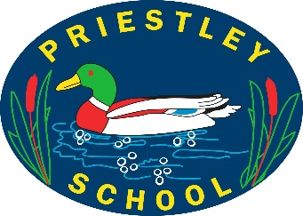
W/C: 13/07/2020 Learning Project - TRANSITION
Age Range: EYFS
This week’s learning project focuses on supporting your child with transitioning to their new class.
It will give them the opportunity to reflect on their time in their current class, discuss their favourite memories and achievements whilst also considering their hopes and dreams for the next academic year.
Transition Activities
MEMORIES | Monday- Over the last year, your child will have created many school memories that they will cherish forever. Capture these memories in a fun way by asking your child to create a drawing or painting that illustrates their favourite school memory. This could be of a memorable lesson, a school trip or a game they played with friends. If your child has more than one favourite memory, they could create multiple art pieces and put these together to create a collage. Share at ask@priestly.wilts.sch.uk
ACHIEVEMENTS | Tuesday- Your child has achieved so much over the course of the year and now it is time to reflect on what makes them proud. Talk to your child about their proudest achievement this year. This could be learning to read some simple words, holding a pencil correctly or eating all of their school lunch every day.  After discussing your child’s accomplishments, ask them to choose one. Work together to create a portrait of your child which depicts their proudest achievement. This could then be shared with their new class teacher in September. Your child may wish to also draw a portrait of their new class teacher, they could do this by looking at a photograph of their new class teacher on the school website.
SAYING FAREWELL | Wednesday- Ending the academic year is a time for your child to say farewell to current teachers and sometimes to classmates too. Talk to your child about the friendships they have made this year. Who is important to them and why? What are they going to miss most about their teacher/teachers? Support your child to draw around their hand on paper and then carefully cut it out. On the template, ask your child to draw or write a goodbye message to a friend or teacher. On each finger, with support, they could write the qualities that this special person has displayed over the year e.g. kindness, being helpful, etc.
INDIVIDUAL QUALITIES | Thursday- Ask your child to think about what makes them special. What makes them different to other people? Using an old shoe box, make a ‘Special About Me’ box. Your child could collect items from around the house that represent their personality such as a paintbrush, a storybook or a pair of dance shoes. Alternatively, your child could carefully cut out pictures from magazines or draw pictures to represent their individual qualities. Talk about the importance of being unique together .
GOAL SETTING | Friday- Read or listen to the story ‘Giraffes Can’t Dance’ here. Talk about how Gerald the giraffe showed determination when trying to achieve his goals. Ask your child what they are looking forward to most about their new class, what they would like to get better at and what they would like to learn about.  Then discuss all of the things that will help your child get read for their new year group (see the list below). With your child, choose a few of the items from the list to practise over the next few weeks before September.

EYFS Transition Learning Project
Below are some ideas of how your child could set out their work.
MEMORIES | ACHIEVEMENTS | SAYING FAREWELL | INDIVIDUAL QUALITIES | GOAL SETTING
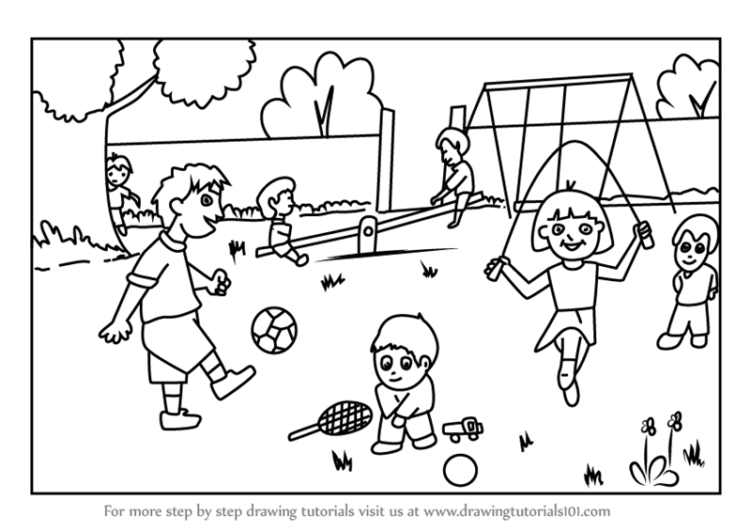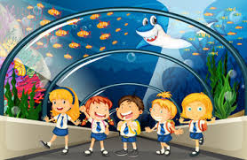 | 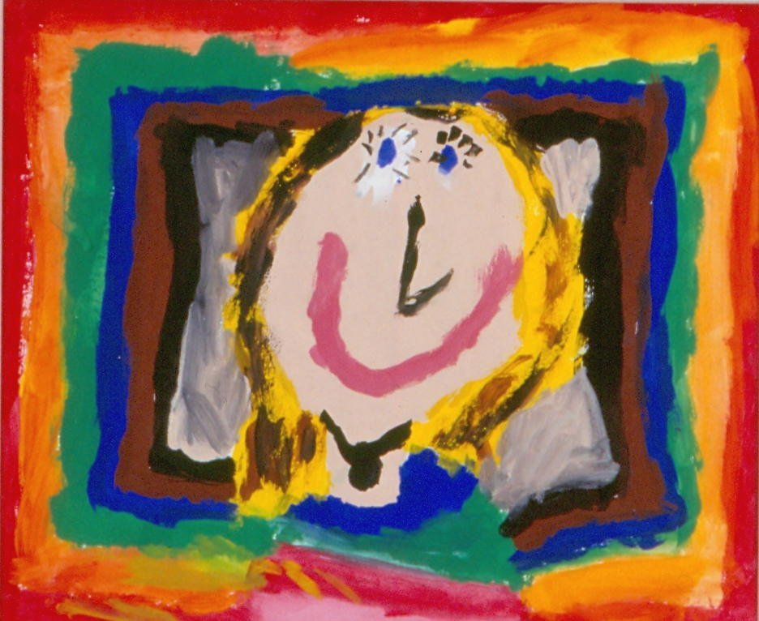  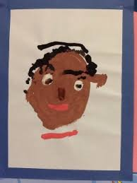 |  | 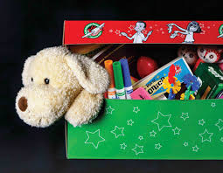 | - Taking turns when playing games  - Putting on my P.E kit independently  - Putting equipment away when I have finished using it  - Writing my first and last name  - Washing and drying my hands  - Using scissors safely  - Pouring water from a jug
Additional Learning Resources Parents May Wish To Engage With:
- Tips and resources to support transition from Mentally Healthy Schools can be found here.
- Childline wants to help bring out the best in your child through some easy-to-do activities.
- The BBC Bitesize website has lots of helpful videos to support transition for both parents/carers and children.
- Parentkind provides handy hints to help prepare your child for their new class.

