Learning Project - Famous & Significant People
Age Range: EYFS
Weekly Reading Tasks | Weekly Phonics Tasks
Monday- Ask your child to think about their favourite books and read one of them together. Find out about the famous authors and encourage your child to think about why they like these books? | Monday- Sound Sprint - Make some sound cards (you could use paper). Place and spread them out across the floor. Ask your child to run and stand on the sound you call out. Say simple words as a challenge e.g. f-o-x.
Tuesday- Read stories written by the famous author, Julia Donaldson. You can also listen to them if you click on the following links: Room on the Broom / Gruffalo. | Tuesday- Play Online Buried Treasure - Click on the sounds your child is learning. CHALLENGE: If you think it is a real word can you explain what the word means?
Wednesday- Ask your child to draw pictures showing what happened at the beginning, middle and the end of Room on the Broom or The Gruffalo. Or choose a different story. | Wednesday- Ask your child to use their phonic knowledge to spell some of the names of the characters from the ‘The Gruffalo’? E.g. f-o-x, ow-l. If this is too tricky, can they say the sounds that make up the words instead?
Thursday- Ask your child questions about the books that you have shared- Who are the main characters? How are the characters feeling? Who is your favourite character? Why? What did you like/dislike about this story? | Thursday- Play Viking Full Circle - Click on the set of sounds your child is learning. Listen carefully to the word and have a go at choosing the correct letters to make the word.
Friday- Your child can continue to read a story from the free eBook library at Oxford Owl. Repeat as you would your class reading books. | Friday- Choose a letter of the alphabet. How many famous people or book characters can your child think of that start with this letter?
Weekly Writing Tasks | Weekly Maths Tasks- Adding
Monday- Watch ‘The Gruffalo’ here. Ask your child to draw a picture of their favourite character. Can they write words/sentences to describe their character, i.e. furry body, knobbly knees and black teeth. | Monday- Practice counting on from any given number. Try to create rhythmic patterns: 1,2 3,4, 5,6 2,3,4, 5,6,7 8,9, 10. Then play this online adding machine game, add up the animals and objects.
Tuesday- Can your child make a wanted poster for the Gruffalo. Can they draw a picture of the Gruffalo? Can they describe him? | Tuesday- Use the Tens Frame to add numbers together. Or, ask your child to make 10 using different objects from around the house/garden e.g. dry pasta.
Wednesday- Your child can practise writing letter families (t, l, i) in fun ways e.g. with their finger in shampoo or with a wet sponge on the pavement. | Wednesday- Adding numbers: Watch Numberblocks (clip 1) to support with adding. You can also click on clip 2 or clip 3.
Thursday- Ask your child to think about who they believe to be important people – such as the Queen. How would your child describe them? Why do they think they are important? Your child could list important people. | Thursday- Generate your own addition number stories: First, there are 3 people on the bus. Then, 2 more people get on the bus. How many people are on the bus? Now there are 5 people on the bus.
Friday- Ask your child to think about and draw someone who is very important to them. Can your child say or write a simple sentence describing why this person is so important. | Friday (theme)- Make a pretend shop using items from the kitchen cupboard. Ask your child to pretend to be the shopkeeper and do different things such as sell the food, sort it into groups such as types of food, sizes, weights etc.

Learning Project - to be done throughout the week
The project this week aims to provide opportunities for your child to learn more about famous or significant people. Learning may focus on past or present inventors, explorers or scientists and how they influence society today.

Make your Favourite Characters-
- Make a puppet of a famous story character. Use a toilet roll and draw, colour and stick other bits of material onto the tube to make your own character puppet. This can be a character from the Gruffalo or a character from another story written by a different famous author.
- Paint your hand and make handprints and decorate to make your very own Gruffalo.

Can you Name the Famous Characters?
- Take part in the quiz -Who Do You Know? You will need help from your grown ups. Have a go at Quiz 1 and Quiz 2. Or, you could also describe famous book characters to your child and they have to guess who it is you’re describing.

Play Snake
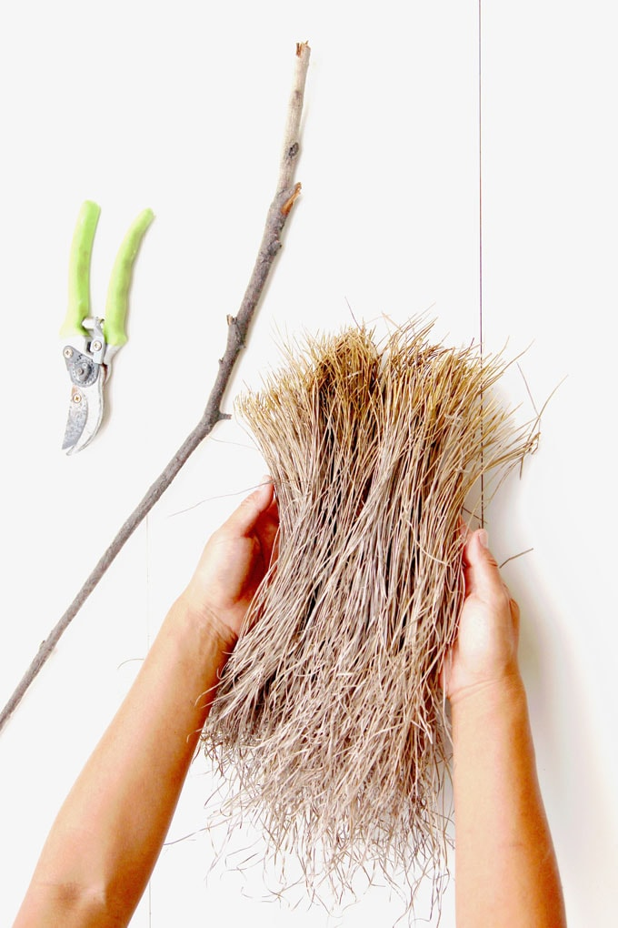
- The Gruffalo features a snake. Click here to play snake - Use the arrows on the keyboard to move the snake around - count how many apples you can collect. Or, play a family game of Snakes and Ladders.

Create your own Broomstick
- Create your own broomstick like the witch in ‘Room on the Broom’. You could gather up sticks from the garden and tie them on to the end of a large stick using elastic bands, string or garden twine. How could you make improvements to your broom? Encourage your child to act out the story. Take a photograph of your finished broomstick and upload to ask@priestley.wilts.sch.uk

Visit ‘The Gruffalo’ website
- Listen to the Gruffalo song, learn the ‘Monkey Puzzle’ song in makaton and dance along to the ‘Gruffalo’s Child’ song. There are also some great interactive games in the play and explore area. Colour your own Gruffalo using the paint game, create your own monster on monster maker and much more.
STEM Learning Opportunities #sciencefromhome
Rose Mitchtom and Margarette Steife
- Over 120 years ago two women came up with the idea to make a teddy bear. Collect all your teddy bears. Are they all the same? What do you think makes a good teddy bear? If you were going to invent a new teddy bear what would it look like?
Additional learning resources parents may wish to engage with
White Rose Maths online maths lessons. Watch a lesson video and complete the worksheet (can be downloaded and completed digitally).
Numbots. Your child can access this programme with their school login.
IXL Click on Maths, Reception. There are interactive games to play and guides for parents.
Talk for Writing Home-school Booklets are an excellent resource to support your child’s speaking and listening, reading and writing skills.
The Learning Projects are based on the National Curriculum expectations for the key stage which your child is in. It may be that your child finds the tasks set within the Learning Project for their year group too simple. If this is the case, then we suggest that your child accesses the Learning Projects which are set for the key stage above. Equally, if the projects are too challenging, then we advise that your child accesses the projects for the key stage below.

