

Y6 Transition

Science

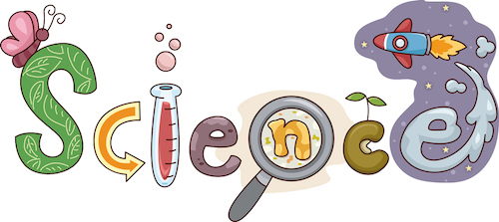

Understanding articles

A Y6 Transition Project from Kingsbury Green Academy

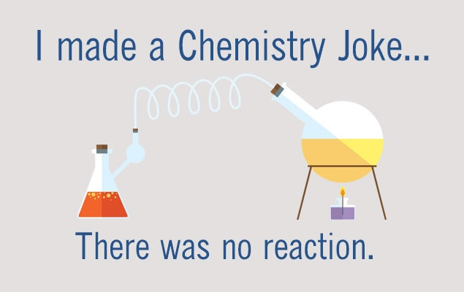

Science is not “knowing lots of things”.

Science is about a way of thinking and questioning what is around us. To be a good scientist you just need to be good at questioning and studying the world around you. This will give you a chance to show how good a scientist you are

[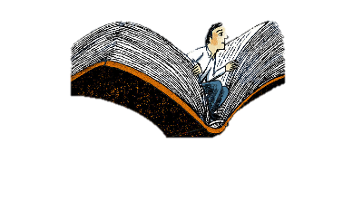](https://www.google.com/url?sa=i&url=https%3A%2F%2Fwww.sciencemag.org%2Fcareers%2F2019%2F11%2Fescape-stress-grad-school-i-read-fiction&psig=AOvVaw3nrY7jbrF-hhACKAvtbDE8&ust=1589540829657000&source=images&cd=vfe&ved=0CAIQjRxqFwoTCLDd75mbs-kCFQAAAAAdAAAAABAD)

Read and enjoy the extracts to get you thinking.

Use these symbols to guide you through each activity.

[](https://www.google.com/url?sa=i&url=https%3A%2F%2Fworqiq.com%2F2018%2F09%2Fopen-to-think-pure-thinking-power%2F&psig=AOvVaw0bSvE23Xd0T_Uzd1tH00iz&ust=1589542521564000&source=images&cd=vfe&ved=0CAIQjRxqFwoTCOCBhMGhs-kCFQAAAAAdAAAAABAD)

Think – use the questions to develop your ideas.

[](https://www.google.com/url?sa=i&url=https%3A%2F%2Fpowerpoetry.org%2Factions%2Fhow-make-poem-getting-started-poetry&psig=AOvVaw0XSthyQZh8PKqh4cIaRzBQ&ust=1589542600589000&source=images&cd=vfe&ved=0CAIQjRxqFwoTCJCMs-ahs-kCFQAAAAAdAAAAABAD)

Write – put your ideas down on paper!

[](https://www.google.com/url?sa=i&url=https%3A%2F%2Fpowerpoetry.org%2Factions%2Fhow-make-poem-getting-started-poetry&psig=AOvVaw0XSthyQZh8PKqh4cIaRzBQ&ust=1589542600589000&source=images&cd=vfe&ved=0CAIQjRxqFwoTCJCMs-ahs-kCFQAAAAAdAAAAABAD)

Activity One: The “Scientist”

[](https://www.google.com/url?sa=i&url=https%3A%2F%2Fworqiq.com%2F2018%2F09%2Fopen-to-think-pure-thinking-power%2F&psig=AOvVaw0bSvE23Xd0T_Uzd1tH00iz&ust=1589542521564000&source=images&cd=vfe&ved=0CAIQjRxqFwoTCOCBhMGhs-kCFQAAAAAdAAAAABAD)What do you think of when you imagine a scientist?

How would you describe the way they look or act?

Can you think of a famous scientist?

***Describe your scientist***

On the lines below I would like you to describe a “scientist”. In the box draw what you think they look like.

[](https://www.google.com/url?sa=i&url=https%3A%2F%2Fpowerpoetry.org%2Factions%2Fhow-make-poem-getting-started-poetry&psig=AOvVaw0XSthyQZh8PKqh4cIaRzBQ&ust=1589542600589000&source=images&cd=vfe&ved=0CAIQjRxqFwoTCJCMs-ahs-kCFQAAAAAdAAAAABAD)___________________________________________________________________________________________________________________________________________________________________________________________________________________________________________________________________________________________________________________________________________________________________________________________________________________________________________________________________________________________________________________________________________________________________________________________________________________________

[](https://www.google.com/url?sa=i&url=https%3A%2F%2Fworqiq.com%2F2018%2F09%2Fopen-to-think-pure-thinking-power%2F&psig=AOvVaw0bSvE23Xd0T_Uzd1tH00iz&ust=1589542521564000&source=images&cd=vfe&ved=0CAIQjRxqFwoTCOCBhMGhs-kCFQAAAAAdAAAAABAD)Activity Two: Big question

Is there a scientific question that you have always wanted to know the answer to?

How could you find out the answer to your big question?

For example lots of people want to know “Why is the sky blue”?

[](https://www.google.com/url?sa=i&url=https%3A%2F%2Fpowerpoetry.org%2Factions%2Fhow-make-poem-getting-started-poetry&psig=AOvVaw0XSthyQZh8PKqh4cIaRzBQ&ust=1589542600589000&source=images&cd=vfe&ved=0CAIQjRxqFwoTCJCMs-ahs-kCFQAAAAAdAAAAABAD)***What is your big question?***

***_________________________________________________________________________________________________________________***

Find out the answer to your big question. You could use people, books or the internet to help you.

Write down the answer to your question below.

___________________________________________________________________________________________________________________________________________________________________________________________________________________________________________________________________________________________________________________________________________________________________________________________________________________________________________________________________________________________________________________________________________________________________________________________________________________________

[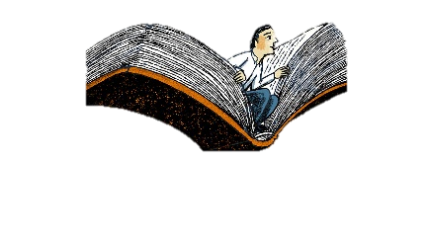](https://www.google.com/url?sa=i&url=https%3A%2F%2Fwww.sciencemag.org%2Fcareers%2F2019%2F11%2Fescape-stress-grad-school-i-read-fiction&psig=AOvVaw3nrY7jbrF-hhACKAvtbDE8&ust=1589540829657000&source=images&cd=vfe&ved=0CAIQjRxqFwoTCLDd75mbs-kCFQAAAAAdAAAAABAD)Activity Three: Science keywords

Read through the list of science keywords below. Most of these you will need to know by the end of year 7. Which ones do you know the meanings of?

Hazard flammable toxic luminous non-luminous combustion

Fuel oxygen Variable Acid Alkali independent

Corrosive Irritant Organic Indicator Conclusion Evaluation

Equipment Method

[](https://www.google.com/url?sa=i&url=https%3A%2F%2Fpowerpoetry.org%2Factions%2Fhow-make-poem-getting-started-poetry&psig=AOvVaw0XSthyQZh8PKqh4cIaRzBQ&ust=1589542600589000&source=images&cd=vfe&ved=0CAIQjRxqFwoTCJCMs-ahs-kCFQAAAAAdAAAAABAD)

Choose 5 words from the list above that you don’t know the meaning of. Write the keywords below and research what they mean

|  |  |
| --- | --- |
| Keyword | Meaning |
|  |  |
|  |  |
|  |  |
|  |  |
|  |  |

Activity Four: Apparatus

[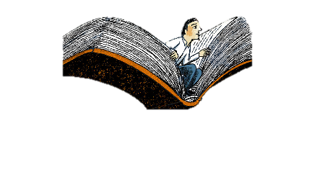](https://www.google.com/url?sa=i&url=https%3A%2F%2Fwww.sciencemag.org%2Fcareers%2F2019%2F11%2Fescape-stress-grad-school-i-read-fiction&psig=AOvVaw3nrY7jbrF-hhACKAvtbDE8&ust=1589540829657000&source=images&cd=vfe&ved=0CAIQjRxqFwoTCLDd75mbs-kCFQAAAAAdAAAAABAD)

Below is a range of equipment that you will use next year in science lessons. For each one look at the spelling and try to think how it could be used.

|  |  |  |  |  |
| --- | --- | --- | --- | --- |
| **Picture** |  | **Diagram** |  | **Name** |
| ..\..\wmfs\3d versions\test tubes.wmf |  |  |  | **Test tube** |
|  |  | ..\wmfs\Symbols\Tripod symbol.wmf |  | **Tripod** |
| E:\Equipment extras\TT rack thumbnail.JPG |  | E:\Equipment extras\TT rack symbol.wmf |  | **Test tube rack** |
|  |  | ..\wmfs\Symbols\Gauze.wmf |  | **Gauze** |
| ..\..\Thumbnails\Measuring cylinder.jpg |  |  |  | **Measuring Cylinder** |
| ..\..\Thumbnails\funnel drawn.jpg |  |  |  | **Funnel** |
| **E:\Thumbnails\Basin drawn.jpg** |  | ..\..\wmfs\Symbols\Evaporating.wmf |  | **Evaporating dish** |
| E:\Thumbnails\Conical flask drawn.jpg |  | ..\..\wmfs\Symbols\Conical flask.wmf |  | **Conical Flask** |
| ..\wmfs\Stand drawn.wmf |  | ..\..\wmfs\Symbols\Stand symbol.wmf |  | **Clamp stand** |
| Colour bunsen thumbnail.JPG |  | E:\Equip. drawn\wmfs\Symbols\Heat.wmf |  | **Bunsen burner** |
| ..\..\Thumbnails\beaker drawn.jpg |  | ..\wmfs\Symbols\Beaker.wmf |  | **Beaker** |
| E:\Thumbnails\Thermometer.jpg |  | E:\Equip. drawn\wmfs\Symbols\Thermometer.wmf |  | **Thermometer** |

[](https://www.google.com/url?sa=i&url=https%3A%2F%2Fpowerpoetry.org%2Factions%2Fhow-make-poem-getting-started-poetry&psig=AOvVaw0XSthyQZh8PKqh4cIaRzBQ&ust=1589542600589000&source=images&cd=vfe&ved=0CAIQjRxqFwoTCJCMs-ahs-kCFQAAAAAdAAAAABAD)**Apparatus diagrams**

It is important to be able to draw the equipment we use in science.

Using a pencil and ruler (if you have one) carefully draw the diagrams (not the pictures) for the apparatus below

|  |  |
| --- | --- |
| **Name** | **Diagram** |
| **Test tube** |  |
| **Tripod** |  |
| **Test tube rack** |  |
| **Gauze** |  |
| **Measuring Cylinder** |  |
| **Funnel** |  |
| **Evaporating dish** |  |
| **Conical Flask** |  |
| **Clamp stand** |  |
| **Bunsen burner** |  |
| **Beaker** |  |
| **Thermometer** |  |

Activity Five: Observation skills[](https://www.google.com/url?sa=i&url=https%3A%2F%2Fworqiq.com%2F2018%2F09%2Fopen-to-think-pure-thinking-power%2F&psig=AOvVaw0bSvE23Xd0T_Uzd1tH00iz&ust=1589542521564000&source=images&cd=vfe&ved=0CAIQjRxqFwoTCOCBhMGhs-kCFQAAAAAdAAAAABAD)

A large part of the scientific process is observing what happens in an experiment.

Sometimes it is obvious what is happening, sometimes it is harder to figure out.

[](https://www.google.com/url?sa=i&url=https%3A%2F%2Fpowerpoetry.org%2Factions%2Fhow-make-poem-getting-started-poetry&psig=AOvVaw0XSthyQZh8PKqh4cIaRzBQ&ust=1589542600589000&source=images&cd=vfe&ved=0CAIQjRxqFwoTCJCMs-ahs-kCFQAAAAAdAAAAABAD) ***You will now practise your observation skills***

***Start by watching an experiment online, or if you can find a safe experiment you can carry out at home (with permission)***

**There is a good Youtube video by MrDuck call 10 amazing science experiments**

Watch the experiment carefully then try to explain what you can see happening. If you are unsure try to research to find an answer. Only write down things that you understand. ____________________________________________________________________________________________________________________________________________________________________________________________________________________________________________________________________________________________________________________________________________________________________________________________________________________________________________________________________________________________________________________________________________________________________________________________________



We hope you’ve enjoyed working through these activities and thinking about science. We would love to see your work in September. Until then, have a great summer

